Q4. After installing git, pull your repository named ‘linux_scripts’. Run scripts inside this repository on ec2 instance. Take screenshots and save them in a docx file.

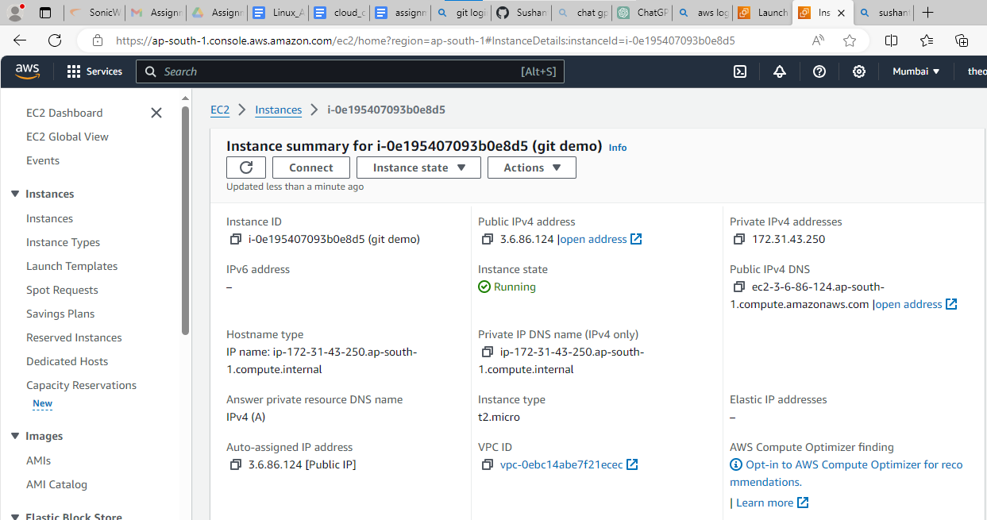

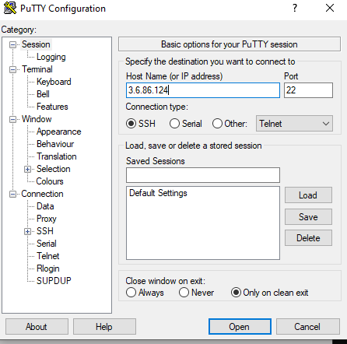

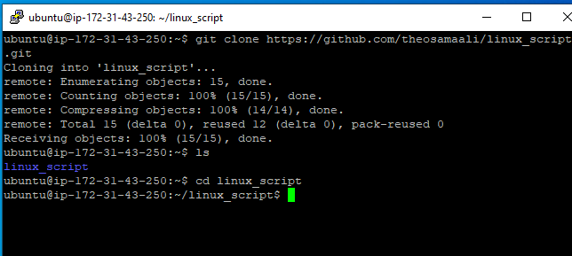

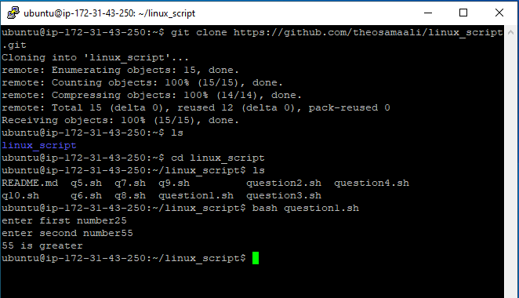

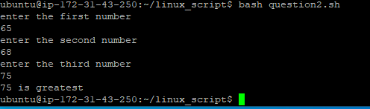

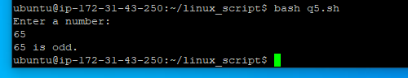

C:\Users\dbda\Desktop\cloud assignment 4\q 4.4.png